**Content：**

There are six pages in total, The website is about me, the first is my picture about my childhood.

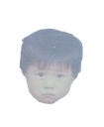(Size: 80*100)

The second is a map about my hometown.

[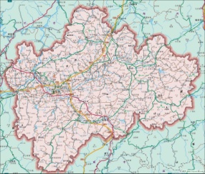](javascript:void(0)) 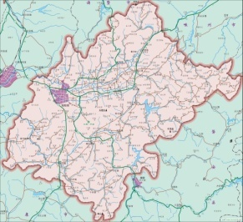 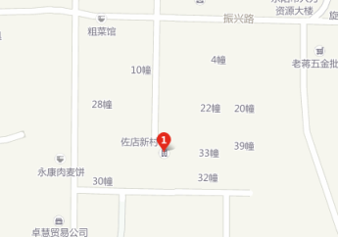

ZHEJIANG Province Dong yang Province

[http://map.sogou.com/#c=13385987,3387463,15&lq=%u4E1C%u9633%u5E02%u4F50%u5E97%u65B0%u6751&where=13384777.34375,3385865.234375,13387191.40625,3389064.453125,0&page=1,10](http://map.sogou.com/%23c=13385987,3387463,15&lq=%u4E1C%u9633%u5E02%u4F50%u5E97%u65B0%u6751&where=13384777.34375,3385865.234375,13387191.40625,3389064.453125,0&page=1,10)

The third is photos of the environment around my house.

The forth is about my childhood experience.

The fifth if about the future imagined. The sixth is about my family.